
Lesson 7: On the Move
Unreal Engine (optional advanced track)
VIDEO GAME CREATION
This week: enemies stop standing still. Your job is to make every enemy advance slowly toward the player, and clean up any that reach the bottom of the screen without being shot.
Open your own [YourName]Game project from Lesson 6 - don't start a new one.
Tip: no new assets this week - this is a logic-only lesson.

Setup
- Open your [YourName]Game project from Lesson 6.

Level 1 - Minimal (MVP)
Every enemy moves slowly downward, toward the player, instead of sitting still. An enemy that reaches the bottom of the screen unshot is removed - and does NOT count toward your win condition, since it escaped rather than being defeated.
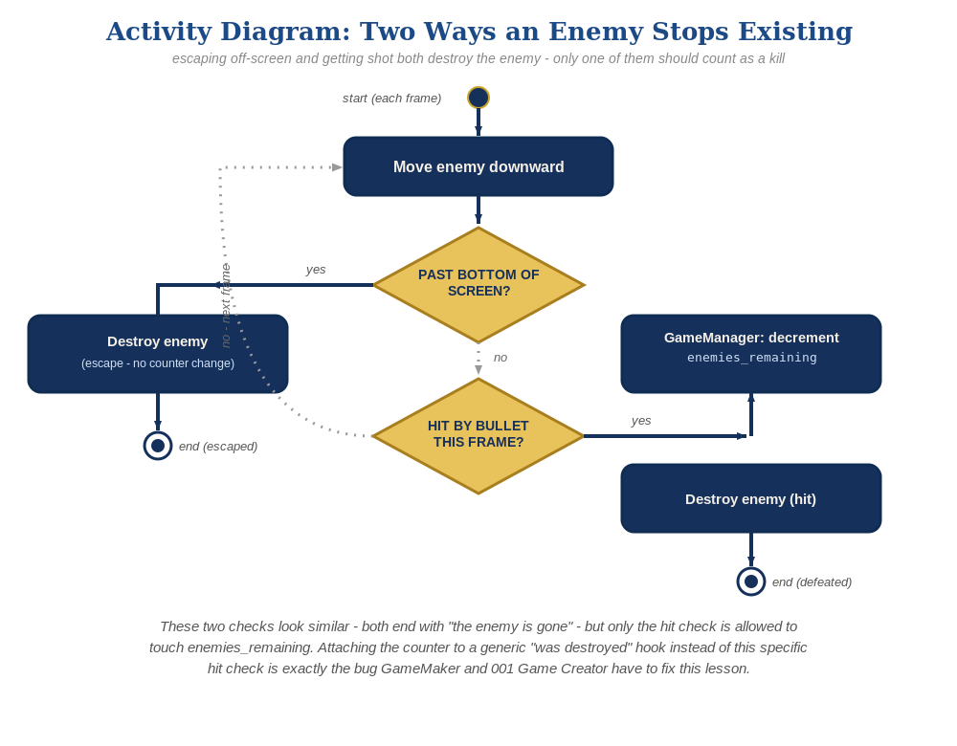
The general escape-vs-hit distinction behind this week's exercise - the same shape in every engine, whatever the exact code or blocks look like.
- In BP_Enemy, add a float variable EnemySpeed (default around 50).
- In BP_Enemy's Event Graph, add an Event Tick node feeding an "Add Actor World Offset" node. Right-click its Delta Location pin and choose "Split Struct Pin" first (it starts collapsed as one Vector pin, and won't accept a value into just Y until it's split), then wire -EnemySpeed * DeltaSeconds into Y (negative, since this course's Y+ convention is "up"). Add a Branch checking its own Y location against an off-screen-at-the-bottom threshold, feeding a plain "Destroy Actor" node on True - not the OnEnemyDestroyed dispatcher.
- Click Compile, then Play and let the enemies drift downward - shooting one should still work exactly as before, and letting one reach the bottom unshot should just destroy it, with no "You Win!" message.
BP_Enemy's Event Graph (new):
Event Tick ->
Add Actor World Offset(Self, DeltaLocation = (0, -EnemySpeed*DeltaSeconds, 0))
Event Tick ->
Branch(GetActorLocation().Y < -400) -> True: Destroy Actor(Self)
(plain Destroy Actor here - do NOT call OnEnemyDestroyed)
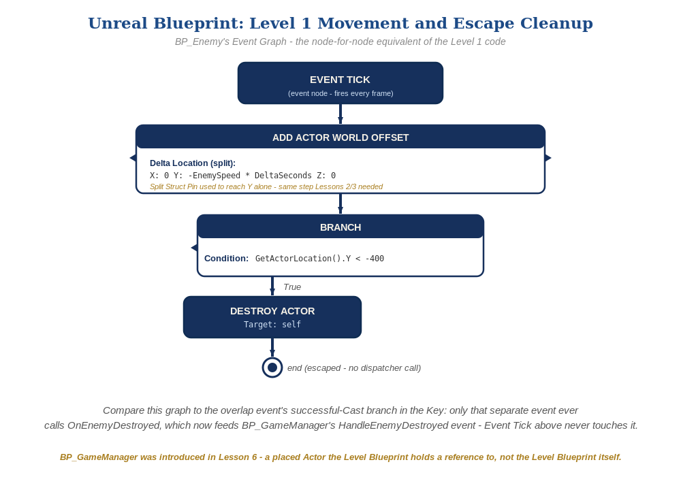
BP_Enemy's Event Tick graph, in Unreal Blueprint - the node-for-node equivalent of the Level 1 code.

Alternate Path: C++ (code, optional advanced track)
The same movement-and-cleanup pattern, and the same escape-vs-hit distinction, work in C++ instead of Blueprint nodes.
- In ACppEnemy's Tick(), call AddActorWorldOffset() along -Y, then check GetActorLocation().Y against your off-screen threshold and call a plain Destroy() when past it - not OnEnemyDestroyed.Broadcast().
- Confirm OnEnemyDestroyed.Broadcast() still only appears inside OnOverlap(), never inside Tick().
// ACppEnemy.cpp
void ACppEnemy::Tick(float DeltaSeconds) {
Super::Tick(DeltaSeconds);
AddActorWorldOffset(FVector(0.f, -EnemySpeed * DeltaSeconds, 0.f));
if (GetActorLocation().Y < -400.f) {
Destroy();
}
}
This mirrors the Blueprint path's Event Tick and escape Branch - same underlying engine calls, just from code. The escape-vs-hit distinction lives in which function calls Destroy(), the same in both paths.

Level 2 - Complete (Alpha/Beta)
A moving enemy can still be shot and destroyed correctly, and an enemy that escapes off the bottom never triggers "You Win!" by accident.
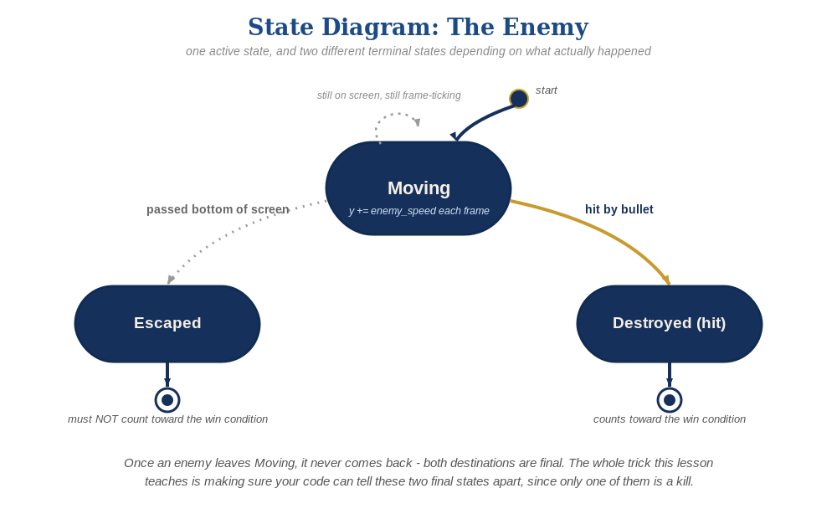
The enemy's two possible endings this week - only one of them should count as a kill.
- Shoot a moving enemy to confirm Event ActorBeginOverlap still fires correctly while it's in motion.
- Let at least one enemy escape off the bottom unshot, and confirm "You Win!" does NOT appear - only the successful-Cast branch (a real hit) ever calls OnEnemyDestroyed, and the escape-cleanup Branch never does.

Level 3 - Refined (Ready to Publish) - pick any that interest you
- Visual: randomize EnemySpeed slightly in BeginPlay (e.g. EnemySpeed = FMath::RandRange(40.f, 70.f) via a Random Float in Range node) so enemies don't all move in perfect lockstep.
- Structure: keep BP_Enemy's escape-cleanup Branch calling only Destroy Actor, with the OnEnemyDestroyed broadcast staying exclusively inside the overlap event's successful-Cast branch.

If Something's Wrong
- Enemies don't move at all: confirm Event Tick is actually wired to the Add Actor World Offset node, and EnemySpeed is greater than 0.
- Can't wire -EnemySpeed*DeltaSeconds into just the Y of Delta Location - it only shows one combined Vector pin: right-click that pin and choose "Split Struct Pin" to break it into separate X/Y/Z pins first, the same step Lessons 2 and 3 needed.
- "You Win!" appears even when enemies escaped unshot: confirm the escape-cleanup Branch's True case only has a plain Destroy Actor node, with no Call OnEnemyDestroyed nearby.
- Enemies move but never disappear at the bottom: confirm the GetActorLocation().Y < -400 threshold actually matches your level's visible play area.

Want More?
dev.epicgames.com/community/learning, Student Resource List > Unreal

